Communication Plan
Introduction 2
Purpose 2
Objectives of Communication 2
Guiding Principles for Communication 2
The Approach 3
1. Confirm Objectives and Guiding Principles of Communication 3
2. Confirm Stakeholder Groups 4
3. Identify Key Messages 4
4. Select Communication Channels 5
5. Develop the Communication Plan
6. Implement / Review the Communication Plan 6
7. Update Project Aim plan 6
8. Monitor and Measure Project Aim Plan 6
The Stakeholder Groups 6
The Communication Plan 8
End Users 8
The Steering Committee 10
Business Managers 11
Reporting Users 12
Indirect Users 14
The Project Team 16
Expert Users 17
Customers and Suppliers 18

Introduction

Purpose
During an implementation, there are numerous groups of people who are affected directly and indirectly by the project. In addition, there are a number of groups in the organization who need to support the implementation project. In many cases, the project may be at risk when communication with these people is ineffective or insufficient.
Communication is essential to maintain the pace of the project and eliminate delays. All personnel must be kept informed of the progress of the project and key milestones relevant to their business. Audience groups can be anyone within the scope of the new enterprise system who is directly or indirectly affected. This pertains to people both inside and outside of the organization, such as customers, suppliers, end users, and so on.
For the project, effective and efficient communication is one of the key success factors of the project, so it is vital that a consistent and well-defined approach is documented.
The purpose of this document is to
- Define the key drivers for communication in the project
- Define the overall guiding principles and strategy for communication
- Define clearly what this means in terms of specific events and activities

Objectives of Communication
Communication in the project will:
- Provide tailored, timely information
- Inform and involve users affected indirectly, but whose understanding is required
- Develop awareness, ownership and understanding of all parties involved
- Distribute accurate information to eliminate inconsistent messages and errors
- Develop realistic expectations regarding impact and benefits
- Gain business ownership and support for the project
- Provide tailored, timely information
- Inform and involve non-users whose understanding is required.
- Collect information to help identify risks and progress on their mitigation

Guiding Principles for Communication
Development of guiding principles should include meetings with:
- The Program Managers and Project Managers
- The Corporate Communications department
- Human Resources
- The Training and Change Managers on the Project
- The Project Steering Committee

The following are examples of best practice communication guidelines:
All Communications in the project will be:
- Tailored locally for all audience groups
- Clear, simple and concise to eliminate problems in translations
- Developed and presented using the formats, fonts, color schemes and logos defined by the project standards
- Delivered by local audiences and by local leadership where possible
- Written or delivered using informal wording and techniques that reflect the cultural values of the Organization
- Engage audiences where necessary to ensure successful communication

The Approach
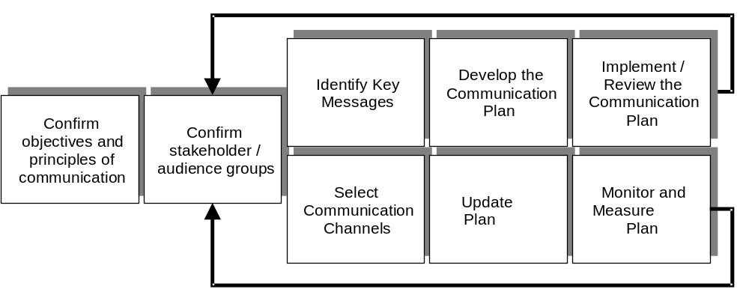

Diagram 1: The Communication Approach

1. Confirm Objectives and Guiding Principles of Communication
The purpose of this activity is to:
- Confirm the overall objectives of communications,
- Outline the scope of communication and guiding principles that need to be followed to ensure success.
The objectives and guiding principles are documented in the Introduction section.

2. Confirm Stakeholder Groups
The purpose of this phase is to ensure that the correct groupings of stakeholders have been identified for the project. The following questions were considered to identify an initial list of stakeholder groups:
- What user groups in terms of the process areas or departmental groups are affected?
- Which groups of people will the users interact with who may need to be aware of procedural changes?
- Who in the organization do the users report to, and who in particular is responsible for providing resources for the project (for example, approval of time for user training)?
- For each process area affected, who are the key external customers and suppliers who need to be involved in the project?
- Who in the organization will need to commit resources and take ownership during the project?
- Who in the organization will need to provide specialist support in aligning the organization or its facilities?
- Which external parties are affected or can influence project success?
Workshops should be conducted with representatives from all the businesses affected. Stakeholder groups were identified based on the following criteria:
- People who are likely to have similar training requirements
- People who are likely to have similar involvement with the project
- People who are likely to have similar communication requirements
- People who are likely to provide similar supporting activities
- People who are at similar levels who may need to lead the project
- People who are likely to have similar change issues
The results of the stakeholder analysis are documented in the Communication Stakeholder Groups section.

3. Identify Key Messages
The purpose of this phase is to identify messages that need to be distributed to each stakeholder group during the various phases of the project. It is important to define messages before you define events to ensure that every piece of project communication on the project has a purpose and an objective. To define the key messages, the following questions were asked for every stakeholder group.
- Which events in the overall project plan affect the stakeholder group, and what type of information are they likely to need as a result?
- Which events during the project could lead to risks communication were lacking with the people affected by the project? Which project events are likely to lead to rumor if they are not covered in a communication?
- How do we communicate to the audience groups to ensure that we generate awareness, understanding, acceptance and ownership? What should be the timing of such events?
The key messages are documented in the Communication Plan section.

4. Select Communication Channels
The purpose of this phase is to define which new and existing communication channels can be used, and to identify which key messages should be distributed down which communication channels. This phase ensures that a realistic view of existing channels is considered before defining new channels unnecessarily.
Interviews are conducted with the following groups:
- Corporate Communications
- Human Resources
- Training and Education Managers on the sites affected
- HR Managers on the sites affected
- Communication representatives on the sites affected
- Training Courses
- E Mail
- Telephone Voice Mail
Usable existing channels identified could include:
- Weekly team meetings in user areas affected
- Local notice boards
- Corporate newsletter
- Union Meetings
- Monthly Director meetings
- Monthly Manager briefs
- Local intranet sites including Manufacturing, Finance, Human Resources and Procurement

New channels could include:
- Portal Demo
- “Road Show” PowerPoint presentation that can be tailored for different audiences by adding or removing slides.
- Mousepads
- Posters
- Information packages

5. Develop the Communication Plan
The purpose of this activity is to create an action plan for the communication activities, assign resources and communicate it to all relevant parties. The plan is outlined in the Communication Plan section.

6. Implement / Review the Communication Plan
The events and materials contained in the plan are due to be rolled out Insert time period. In addition, reviews and feedback mechanisms will also be provided which are documented in the communication plan section.

7. Update the Communication plan
The purpose of this activity is to update the communication plan, ensuring that actions, owners, measures, and completion dates are captured.

8. Monitor and Measure the Communication Plan
The purpose of this activity is to monitor the activities against the communication plan.

The Stakeholder Groups
The following items are not complete and should only be used as examples.

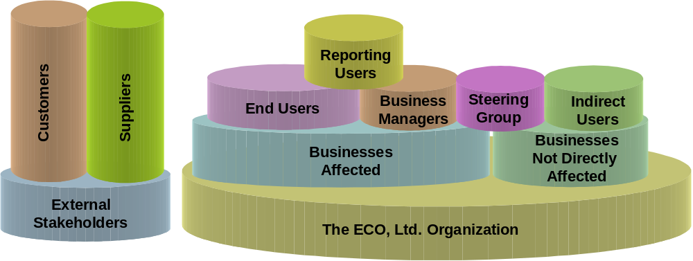Diagram 2: The Stakeholder Groups
End Users are the drivers of the SAP system - using transactions to input data and creating documents to run the business.
The Steering Committee (Group) is a group of business and project directors who have responsibility for governing the project and providing high level direction.
Business Managers are senior representatives of the businesses areas affected by the new system; they provide resources and users to support the project.
Reporting Users use the system on an occasional basis to produce reports. Example: Cost Center Managers.
Indirect Users are users that may not be going live in the system but are affected by other areas in terms of procedural or more indirect change.
Expert Users are representatives from the business areas either full or part time on the project providing business input to the project. This includes involvement in design decisions and transferring knowledge gained to users during training after support after goes live
The Project Team is made up of full time personnel who perform project activities. These include both consultants and people seconded from the businesses.
Customers and Suppliers are those external groups affected by the new system in terms of changes to procedures, systems and /or external documents (such as invoices).

The Communication Plan
The following items are not complete and should only be used as examples. Communication plans can also include the following:
- Event associated with message
- Owners specific tasks
- Dates
- Costs
- Benefit

End Users
Message | Format | Owner | Preparation | Blueprint | Realization | Final Preparation | Go Live
What is the Project trying to achieve and why?  What are the benefits to my department? | “Road Show” delivered by local managers and sponsor | John Smith | ✓
What is the scope of the project?  What functionality will the system bring? | Local workshops with functionality rooms set up | Process Team Leaders  Add Name |  | ✓
What specific changes will occur in my area? | Interviews with affected staff conducted by local managers | Add Name |  |  | ✓
What training will I get?  When will training take place? | Training Catalogue and Training posters | Training Manager  Add Name |  |  | ✓
How can I prepare for Go-live? | Question and Answer pack | Add Name |  |  |  | ✓
How can I get support? | Mouse Mats | Add Name |  |  |  |  | ✓
What is my role assignment(s)? | Training | Add name |  |  |  | ✓ | ✓

The Steering Committee
Message | Format | Owner | Preparation | Blueprint | Realization | Final Preparation | Go Live
What happens during a typical project?  What is planned for this project? | Project Video taken from a case study of another organization | Add Name | ✓
Are all the expectations of the Steering Group members the same, and how is the project going to deliver? How is success measured? | Workshop/Presentation | Add Name | ✓
How is the project being perceived by the business? | Presentation of results from survey and workshops | Add Name | ✓ | ✓ | ✓ | ✓ | ✓
What are the Project AIM Risks and mitigating actions? What is expected of us? | Review of Project AIM plan at every steering committee meeting. | Project Director or Team Lead  Add Name | ✓ | ✓ | ✓ | ✓ | ✓

Business Managers
Message | Format | Owner | Preparation | Blueprint | Realization | Final Preparation | Go Live
What are the benefits of the program?  What are the key messages? | Workshop | Add Name | ✓
What are the key project phases?  What is a typical resource profile? | Internet based presentation demo | Add Name | ✓
What specific changes will occur in my area? | Interviews with affected managers conducted by Human Resources/ | Add Name |  | ✓ | ✓
How can I set a positive example?  What are the key messages? | Workshops  Information material  Help line | Add Name |  |  | ✓ | ✓ | ✓
How do I handle questions from my area? | Standard question and answer packs | Add Name |  |  | ✓ | ✓ | ✓
How do I prepare my staff for Go-live? | Workshops | Add Name |  |  |  | ✓
What will it be like after Go-live? | Workshops | Add Name |  |  |  |  | ✓

Reporting Users
Message | Format | Owner | Preparation | Blueprint | Realization | Final Preparation | Go Live
What is the Project trying to achieve and why?  What are the benefits to my department? | "Road Show" delivered by local managers | Add Name | ✓
What is the scope of the project?  What functionality will the system bring? | Local workshops with functionality rooms set up | Process Team Leaders  Add Name |  | ✓
What training will I get?  When will training take place? | Training Catalogue and Training posters | Training Manager  Add Name |  |  | ✓
How can I prepare for Go-live? | Question and Answer pack | Add Name |  |  |  | ✓
How can I get support? | Mouse Mats | Add Name |  |  |  |  | ✓

Indirect Users
Message | Format | Owner | Preparation | Blueprint | Realization | Final Preparation | Go Live
What is the Project?  What are the benefits to my department? | “Road Show” delivered by local managers | Add Name | ✓
What is the scope of the project?  What changes to the process will occur? | Local workshops | Process Team Leaders  Add Name |  | ✓ |  |  | ✓
What training will I get?  When will training take place? | Training Catalogue and Training posters | Training Manager  Add Name |  |  | ✓
Where can I get more information about bring my business onto the portal? | Information Pack | Portal Team |  |  |  |  | ✓
How can I prepare for Go-live? | Question and Answer pack | Add Name |  |  |  | ✓
How can I get support? | Mouse Mats | Add Name |  |  |  |  | ✓

The Project Team
Message | Format | Owner | Preparation | Blueprint | Realization | Final Preparation | Go Live
What are the benefits of the project?  What key messages should we communicate? | Project Meeting | Program Manager  Add Name | ✓
What can we learn from previous projects? | Interviews, Documentation | Add Name |  | ✓
What can we learn from previous phases? | Workshops, Team-building events | Add Name |  | ✓ | ✓ | ✓
How effective is the communication? | Feedback workshops with sample audience groups, Surveys | Add Name | ✓ | ✓ | ✓ | ✓ | ✓
How is the project perceived by the business? | Presentation of results from survey and workshops | Add Name | ✓ | ✓ | ✓ | ✓ | ✓

Expert Users
Message | Format | Owner | Preparation | Blueprint | Realization | Final Preparation | Go Live
What are the benefits of the project? | Project Meeting | Program Manager  Add Name | ✓
What key messages should we communicate? | Workshop/Training  Information Packages | Add Name |  | ✓ | ✓ | ✓ | ✓
Team Building: What is expected of us on the project?  What are the key activities? | Workshop | Add Name |  | ✓
How do other expert users perceive their role and the changes? What can we do to help them? | Workshops | Add Name | ✓ | ✓ | ✓ | ✓ | ✓

Customers and Suppliers
Message | Format | Owner | Preparation | Blueprint | Realization | Final Preparation | Go Live
What are the benefits of the project to us?  How will our paperwork change? | Brochure | Communication Team and Local Business Managers  Add Name |  |  |  | ✓
Reminder : Go-live | Postcard | Communication Team and Local Business Managers  Add Name |  |  |  |  | ✓

